

CLIENT: | Thelen Subaru | PHONE #:
SPOT: | THEL-SU-T210302 Lot To Love V2 | FAX # :
LENGTH: | :30 | SALES REP: | Larry H
DATE: | 3/10/20 | PRODUCER: | A. Dennis

GRAPHICS | Video | AUDIO
Think Thelen Logo  Euclid Ave. – Bay City  ThelenSubaru.com    2021 Subaru Outback  2020 Kelly Blue Book – Best Resale Value Awards (logo)  Vehicle's projected resale value is specific to the 2021 model year. For more information, visit Kelley Blue Book's KBB.com. Kelley Blue Book is a registered trademark of Kelley Blue Book Co., Inc.  2021 Subaru Outback  Lease From Just 249/mo  Lease For 36 months - $2,784 Due At Signing  0% APR For 63 Months  0% APR for 63 months equals $15.88 per $1,000 financed, regardless of down payment, for well qualified buyers. Cannot be combined with some other offers. 2021 Subaru Outback, Standard Base trim, code MDB-01. MSRP $27,845. Lease for 36 months, 10,000 miles per year for qualified lessees with approved credit. $2,784 due at signing plus dealer fees. No security deposit required. Tax, title, and license fees extra. $0.15 per mile for overage. Other restrictions apply, see dealer for details. Must take delivery by 3/31/2021  2021 Subaru Forester  2021 IIHS Top Safety Pick (logo)  2021 Subaru Forester  Lease From Just $239 /mo  Lease For 36 Months - $2,784 Due At Signing  2021 Subaru Forester, Standard Base trim, code MFB-01. MSRP $25,845. Lease for 36 months, 10,000 miles per year for qualified lessees with approved credit. $2,784 due at signing plus dealer fees. No security deposit required. Tax, title, and license fees extra. $0.15 per mile for overage. Other restrictions apply, see dealer for details. Must take delivery by 3/31/2021  Think Thelen Logo  Euclid Ave. – Bay City  ThelenSubaru.com  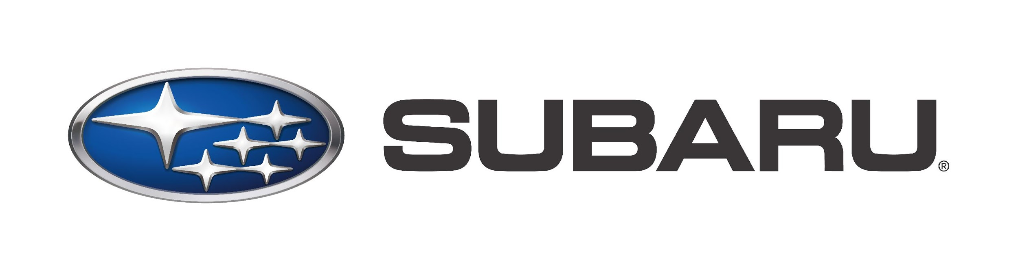 | Text: Thinking About A New Car?  GFX: 2021 Subaru A Lot TO Love Event Logo    GFX: 2021 Subaru Outback photo    GFX: 2021 Subaru Forester photo | Announcer: (:30)  Thinking about a new car? Then Think Thelen, Think Subaru.  During the Subaru A Lot To Love Event, you’ll save on a 2021 Subaru Outback! The vehicle that retains its value better than any other in its class!  Lease yours today for as little as $249 a month! Or choose 0% APR for 63 months!  Or find a lot to love in a 2021 Subaru Forester, an IIHS Top Safety Pick!  Lease yours today for as little as $239 a month!  So Think Thelen. Think Subaru. And expect more from your car dealer!

